BOTBERO: A Semi-Autonomous Firefighting Robot with Short Messaging

Services Notification

Jhune M. Asuncion 1, Mario O. Binas-o Jr. 2, Phillip Jayson K. Dumadag 3,

Gerald M. Dillera 4, Jake Care D. Florita 5, Chalie Dave A. Pelecia 6,

Daniel Resty S. Ramirez 7, Christian R. Rodriguez 8,

Johnrick S. Saludes 9, Christian S. Samuya 10

1asuncionjhune@gmail.com

2mariobinaso9@gmail.com

3phillipjaysondumadag@gmail.com

4rhald0502@gmail.com

5jakeflorita01@gmail.com

6peleciad@gmail.com

7restydaniel8jk@gmail.com

8crodriz7pm@outlook.com

9Saludesjohnrick1@gmail.com

10samuyachristian123@gmail.com

**Abstract**

Purpose - To create a Semi-automatic firefighting robot with short messaging service notifications designed to assist in small fire prevention and mitigate risks associated with significant fires.

Method - Applied research was used to develop a prototype combining hardware and software components. The Embedded Product Development Life Cycle was used as an analytical tool in the development process, guiding the robot's systematic design and construction. The research aimed to bring together various technologies to solve the problem, paying attention to ensuring that the prototype worked efficiently.

Results - The robot detects fires, responds to them, and puts them out. It also promptly sends alerts via short messaging services to respond to emergency situations such as gas leaks and fire detection.

Discussion - This robot exhibits remarkable progress in flame control gear. It serves as a valuable device for lowering firefighter risk and averting loss of lives. The design allows effective fire containment and dependable operation.

Conclusion - With the introduction of improved fire prevention technology, the firefighting robot offers firefighters an incredible fire prevention improvement, enabling them to detect fires and act upon them early.

Recommendations – To improve the robot's adaptation capacity to different fire situations, combining a camera sensor with an artificial intelligence system capable of detecting different flame intensities using visual data would be prudent. Additionally, the motor speed can be increased, and gear ratios can be changed to make the robot faster and lighter. Changing Bluetooth to Wi-Fi is recommended for long-range control over the machine. It may also happen that new battery types developed may allow the robot to stay longer and operate more effectively.

Social Implication – The robot contributes to firefighter safety and effectiveness, potentially reducing fire-related injuries and fatalities while aiding in fire prevention and response efforts.

*Keywords: Emergency response, Fire risk mitigation, Semi-Autonomous firefighting robot, SMS*

**I. INTRODUCTION**

The field of firefighting has long been dangerous due to a lack of technological innovation, and there have been several disastrous losses. Additionally, employees still make mistakes despite receiving meticulous preparation, and the current firefighting methods are ineffective and inefficient. In situations like this, firefighters' lives are primarily at risk. With the help of this device, firefighters will reduce the number of times they risk their lives fighting dangerous fires and catastrophic fire incidents.

Table 1. Fire Incident Report by Bureau of Fire Protection

Table 1 presents the report of the Bureau of Fire Protection (2022); from January to February, the agency reported 1891 fire incidents in 2019, 918 fire incident reports in 2020 were low due to the pandemic lockdown, and 1,844 fire incident reports in 2021. Additionally, the Bureau of Fire Protection (2023) says that from January 1 to March 1, fire incidents numbered 2,520 in 2022, compared to 1,984 fire incidents recorded in 2023. They say that fires usually occur in mercantile areas and industrial areas.

A firefighting robot can assist or replace firefighters in conducting firefighting work, reducing firefighters’ Labor intensity, and improving firefighting and rescue ability and efficiency. Scholars worldwide have been working on developing firefighting robots as robotics technology advances. The robot not only has an autonomous inspection function but also has an automatic fire-extinguishing function. The firefighting sources and flexible appearance do not need an external water source and can move freely around the house.

**Statement of the Problem**

An innovative firefighting robot that can control a fire without endangering human lives. The researchers anticipate that this innovation will develop to help lessen the burden on firefighters.

This study aims to answer these following questions.

1. What is the effectiveness of the firefighting robot in minimizing potential fire outbreak risks to firefighters and homeowners?
2. How does the firefighting robot efficiently respond to a fire situation?
3. What is the sensor's range in detecting a fire, and how does it send an SMS to the user immediately?

**Objectives of the Study**

The researchers focus on the design and development of a semi-autonomous firefighting robot that can be used in indoor areas. It has a short messaging system that can send messages to homeowners to detect fire and locate the source of fire using infrared flame sensors.

The following are the specific objectives:

1. To develop a firefighting robot utilizing a microcontroller board.
2. To integrate sensor technology for fire and gas leak detection.
3. To code using C++ programming language and Arduino IDE.
4. To evaluate the accuracy of the robot according to standard parameters.
5. Implement an SMS notification system that alerts users upon fire or gas leak detection.

**Significance of the Study**

**Community.** This study helps the community raise awareness, especially about some of the houses constructed of light materials. This project will help the neighbourhood by reducing the chances of fires.

**Researchers.** This study helps researchers gain better knowledge and build connections with other researchers.

**Firefighters**. This study will help reduce the risk of a potential fire breaking out and will lessen firefighters' workload.

**Future** **Researchers.** This will add to the body of knowledge and initiatives of future researchers in the field of science and technology. It will be much easier, preferably, to continue exploring new things for research and experimentation.

**Scope and Delimitation**

The type of firefighting robot used in the proposed project was also specified. The components needed in this study for the firefighting robot are the Arduino Mega 2560, Infrared Flame sensor to detect fire, MQ – 5 Gas sensor for gas leaks, Remote control connected via Bluetooth module to guide the robot in navigation through debris, a single cylinder actuator connected to a 5 kilogram of dry chemical fire extinguisher, Stereo speaker for the siren to warn nearby people about the fire detected, GSM SIM800L module to alert the authorized people like owner of the house via SMS that the robot detect fire and gas leak. A robot chassis with wheels, gear motor, Servo Motor, and connecting wires.

The study has encountered significant limitations given the small-scale nature of a firefighting robot. The tiny robot's small load capacity makes it difficult to bring above a 5-kilogram fire extinguisher, which is one major limitation. The IR flame sensor was not accurate outdoors due to the heat factors of the environment. The SIM800L cannot send SMS without enough cellular signal or prepaid balance, and the same applies to Bluetooth connections; for controllers, the user must be nearby.

**II. LITERATURE REVIEW**

**Firefighting Robot alternative for firefighters**

According to Bogue (2021), over the last five years, an increasing number of remote-controlled terrestrial robots and all-terrain vehicles that assist fire crews in challenging environments have been commercially exploited. These robots are fitted with an imager and several sensors, providing firefighters with improved situational awareness and hazard warnings.

As stated by Dhiman et al. (2022), firefighters find it difficult to reach certain areas to extinguish fires due to tight spaces and debris blocking roads. Ensuring firefighters are ready to deal with emergencies in cities and industries remains paramount.

Affirming past research of Talavera et al. (2023), in hostile scenarios, where a reduction in mission time and the risk of an accident is essential, incident response teams must be able to obtain accurate information about the environment. Robotics and remotely sensed technology provide real-time data from fires and dangerous gases to assist emergency planning, which does not put teams in danger.

Conforming to Gómez et al. (2021), preventing, monitoring, and extinguishing forest fires is part of the job. It proposes a system using drone swarms for surveillance, mapping, and monitoring, with three operator roles: mission commander, team leaders, and team members, using virtual and augmented reality interfaces for intuitive control and information access.

As chronicled by Chitti et al. (2020), detecting fire and igniting it is a risky job that endangers a firefighter’s life. The Artificial Intelligence study and engineering have contributed significantly to Robotics. Robots have been deployed in diverse industries such as mining, construction, drugs, etc.

Postulated by Natividad et al. (2021), life is highly inconvenient and dangerous for people in an environment of danger, such as conflagration. This is an inevitable problem that is being dealt with, and dealing with it is a challenge.

Framed by Zadeh et al. (2021), due to growing technological progress and substantial urban development, firefighting services are increasingly difficult to manage in Smart Cities. Reaching the top floors of high-rise buildings is a challenge firefighter’s face.

**The Integration of Short Messaging Services on Fire Detection**

According to Suwariono et al. (2021), a prototype was developed to detect house fires and gas leaks using temperature and gas sensors. The sensors detected fire, which led to the system sending SMS alerts and triggering alarms. Different room scales were used in testing, proving that it works well regardless of size. It monitors and reacts to variations in temperature and gas, thus offering timely warnings.

Linking to the research of Morchid et al. (2024), an Internet of Things (IoT) system designed for fire recognition in the field of smart agriculture, through which sensor devices are connected to a Raspberry Pi 3 B+ computer and supported by a secure website interface. It incorporates an MCP3208 analog-to-digital converter that facilitates rapid gestures on connected devices while presenting information about the initial stage of any blaze.

Wisdom from Kharisma et al. (2021), implemented a fire alarm system based on smoke, heat, and gas sensors integrated with an SMS gateway and an alarm. This system is meant to give timely alerts to reduce the risk or impacts of fire accidents within homes.

Discoveries by Maltezos et al. (2022), introduced SB112, an innovative building sensor system that will improve emergency responses in smart cities by utilizing edge computing and automatic emergency calls. It performed well in latency and real-time fire detection with automated emergency communication.

Ideas portrayed by Aryanti et al. (2021), this research developed a GPS-based fire detection system utilizing smoke and temperature sensors, with its controlling centre being an Arduino Uno microcontroller. When the temperature goes beyond thirty-five °C and smoke levels exceed 50 ppm, the system triggers a buzzer and sends an SMS message containing fire coordinates. In tests, it detected thirty-eight °C in temperature and 128 ppm of smoke, successfully sending out an SMS with the warning message “FIRE available” along with locational coordinates.

As demonstrated by Alsaad et al. (2021), a mobile emergency alarm system (MEAS) is a device that can detect emergencies such as fires, car accidents, and earthquakes. The system has two parts: the first detects the event occurring, tracks its location using GPS, and sends this information through SMS, while the second receives the alert and analyses it to locate the nearest help centre.

**Insights into Arduino ATMega 2560**

Explorations of Rajendran et al. (2024), on the development of a line-tracking robot using different controllers, with a focus on the ATmega 2560. It compares the ATmega 2560 with Arduino and Mbot controllers, noting how each affects students' learning and coding experience. An innovative design integrates all three controllers into a single robot to progressively enhance students' coding skills.

Wisdom from Evalina et al. (2023), propose a remedy for household gas leakages through detection with gas sensors, warnings via LCD, alerts by a siren, and a cut-off valve operated by relay to reduce the risk of fire. Everything is monitored and regulated by an ATmega 2560 microcontroller, which stimulates the system once the sensor detects gas leakage. When the voltage goes down to this limit, the system's operation terminates immediately.

Reflecting on the insights of Rajendran et al. (2024), about teaching student robotics by building a line-tracking robot using controllers like ATmega 2560, Arduino, and Mbot. It compares the pros and cons of each controller and then proposes a hybrid design (M-LTR) that uses all three. The Bot was assessed in simulation, helping students learn coding at different difficulty levels.

Discoveries by Sirre et al. (2024), an IoT-based environmental monitoring system is designed and earned out. This uses an Arduino Mega board and various sensors to measure the air quality, temperature, humidity, sound, and atmospheric pressure. A web interface for this system was created from scratch to provide users who want to access detailed information regarding environmental data, including historical context.

**MQ-5 Gas Sensors for Environmental and Safety Monitoring**

Advocated by Jianchen et al. (2023), explore using the MQ-5 gas sensor with an Arduino Mega to monitor air quality in various environments, from living rooms to terraces. The system shows the MQ-5 sensor performs reliably in stable conditions but varies in less controlled settings. With probabilistic neural networks, the setup achieves near-perfect classification accuracy.

Linking to the research of Alshammari et al. (2020), an IoT-based industrial monitoring system that uses an MQ-5 gas sensor to detect leaks and post data to the cloud. An Arduino processes the sensor data, triggering an alarm with a buzzer and displaying the leakage location on an LCD. The system also activates an exhaust fan to extract leaked gas, aiming to prevent fires and reduce damage.

According to Raghunath et al. (2020), in India, where LPG is widely used for cooking and is highly flammable, the project aims to create a gas leakage warning system for apartments. The network map simulates a system, demonstrating its potential for broader applications in residential areas, oil fields, and sewage lines.

Studies conducted by Yumang et al. (2023), suggest a more secure method of identifying leakages involving LPG butane and propane tanks. Presently, manual testing in gas refilling stations is a potential source of health hazards. In this new system, four sensors are installed in the gas tank chamber which helps in automatically detecting fractures and thereby reducing chances of being exposed to dangerous gases and avoiding calamities.

.

**Infrared Sensors for Flame Detection**

Ideas portrayed by Xavier et al. (2022), explore a new method for detecting fires in real time using a differential PIR sensor and deep neural networks. The PIR sensor captures motion signals, which are processed into images for analysis by a deep convolutional network. The system, featuring the Shuffle Net model, successfully accurately identifies fire and human motion.

As outlined by Sousa et al. (2020), evaluates thermal imaging sensors for fire detection in robotics, focusing on image processing and data analysis. It reviews algorithms for enhancing thermal images and presents methods for analysing sensor performance in fire scenarios. The findings emphasize the integration of thermal cameras into autonomous UAVs for improved fire surveillance.

The study sought to develop by Dufour et al. (2021), the creation of a bi-spectral microbolometer sensor system dedicated to the spectral measurement of the mid and long-wave infrared radiances during wildfires. The results obtained from this research indicate that microbolometers in the mid-infrared region can record fire radiative energy (FRP), thus making them suitable for use in lowly resourceful devices such as unmanned aerial vehicles (UAVs) or nanosatellites that aim at monitoring forest fires.

Studies conducted by Yang et al. (2023), developed and demonstrated a standardized evaluation method for image-based flame detection (IBFD) algorithms. They established a framework with twenty-nine assessment indicators and then applied it to evaluate two versions of YOLOv3 algorithms. The findings validated the usefulness of this technique, suggesting that IBFD standards can be enhanced.

**III. METHODOLOGY**

Table 2. Six Different Classes of Fire

|  |  |
| --- | --- |
| Class A (Solids) | Wood, paper, fabric, and some plastic |
| Class B (Liquids) | Alcohol, ether, gasoline |
| Class C (Gases) | Natural gas and Liquefied Petroleum Gas (LPG) |
| Class D (Metals) | Magnesium, Titanium, potassium, etc. |
| Class E (Electrical Fires) | Electrical appliances, wiring, outlets, etc. |
| Class K/F (Cooking Fats & Oils) | Cooking oil, grease, grill, etc. |

Table 2 provides a comprehensive overview of the various classes of fire, indicating their respective points of origin. The robot can only extinguish Class A, B, C, D, and E types of fire, which is an ABC or Multi-purpose Dry Chemical fire extinguisher composed of monoammonium phosphate. Dry powder chemical is highly effective for electronic fires due to its insulator properties.

**Hardware Components**

Table 3. Hardware Components

|  |  |
| --- | --- |
| Components | Description |
| 12v Battery | Provides the necessary power supply to the system. |
| Linear Actuator | A device that converts electrical energy into mechanical motion. |
| Arduino  Mega 2560 | Arduino Mega is a microcontroller board based on the Atmega2560. |
| Bluetooth Module | A basic circuit which integrated Bluetooth function. |
| Connecting wires | These wires facilitate the flow of electric current, enabling the transmission of signals, power, or data within an electrical or electronic system. |
| Relay | An electrical switch that uses a small amount of current to control a larger amount of current. |
| Dry Chemical  Fire Extinguisher | A type of portable fire extinguisher that uses dry chemical powder to suppress and extinguish fires. |
| Dynamo | A motor or generator used to convert mechanical energy into electrical energy or vice versa. |
| GAS Sensor MQ-5 | Use to detect electrodes in the air, sending electric current. |
| Ultrasonic Distance Sensor | Measures the distance to an object using ultrasonic waves. |
| GSM SIM800L | A cost-effective GSM module that uses four global frequency bands in cellular networks. |
| Infrared Flame sensor | The flame sensor operates by detecting infrared radiation. |
| L298N Driver module | A motor driver module that allows control of the speed and direction of DC motors. |
| LED | A semiconductor light source that emits light when current flows through it. |
| SD Card Module | Allows data storage and retrieval using a micro-SD card. |
| Servo Motor | A motor capable of precise control of angular or linear position, velocity, and acceleration. |
| Steel sheets (1mm thick) and wheels | The structural component for the robot which contains the drivetrain. |

Table 3 presents a comprehensive compilation of all the hardware components utilized in the device, along with their corresponding descriptions. This invaluable resource includes key information that professionals can refer to when seeking a thorough understanding of the device's inner workings.

Table 4. Software Components

|  |  |
| --- | --- |
| Software | Description |
| Arduino IDE | The Arduino IDE (Integrated Development Environment) is a software application that provides a user-friendly platform for programming and uploading code to Arduino microcontroller boards |
| C++ | a versatile, high-performance programming language designed for system and application development |

Table 4 provides a comprehensive overview of the various software components utilized in the device, accompanied by their corresponding descriptions. This table is designed to serve as a valuable reference for professionals seeking a deeper understanding of the software infrastructure employed within the device.

Table 5. Materials Cost

|  |  |  |
| --- | --- | --- |
| Item | Quantity | Amount |
| 12v Battery | 1 | ₱950 |
| Servo Motor | 1 | ₱210 |
| 2nd Hand Arduino Mega 2560 | 1 | ₱700 |
| 3watts speaker | 1 | ₱120 |
| ARD GAS MQ-5 | 1 | ₱100 |
| Battery and Double-Sided Tape | 1 | ₱118 |
| Bluetooth module | 1 | ₱122 |
| Bread Board | 1 | ₱100 |
| Connecting Wires (M2M) | 4 | ₱83 |
| 12v Dynamo Motor 775 rpm | 4 | ₱1,050 |
| Epoxy | 1 | ₱220 |
| Fabricated Wheels | 2 | ₱1,500 |
| Fire Extinguisher | 2 | ₱1,800 |
| GSM SIM800L | 1 | ₱550 |
| IR Flame Sensor | 1 | ₱40 |
| Jumper Wire | 2 | ₱240 |
| L293D MOTOR Driver | 1 | ₱130 |
| LED | 1 | ₱10 |
| Linear Actuator | 1 | ₱1,465 |
| Nuts and Screw | 1 | ₱300 |
| Plain Sheet | 1 | ₱450 |
| Relay | 1 | ₱210 |
| Saw | 1 | ₱180 |
| SD Card Module | 1 | ₱65 |
| Spray Can | 2 | ₱260 |
| Tubular | 1 | ₱280 |
| Ultrasonic Distance Sensor | 1 | ₱49 |
| Welding Rod | 1 | ₱250 |
| Wire bundle | 2 | ₱30 |
| Total | ₱11,582 | |

In table 5 justifies a summary of materials expenses for the project worth a total of ₱11,582. The table contains thirty-four individual items listed individually or in multiples of four, each containing given quantities and amounts. Some key components making up the total costs are: 12V Dynamo Motor-₱1,050; Fire Extinguisher-₱1,800; Linear Actuator-₱1,465, among those expensive items. Other necessary materials, such as connecting wires, epoxy, and jumper wires, are cheap but vital to the project's overall completion. Thus, this table represents all necessary costs incurred while assembling the entire system.

**Analytical Tools**

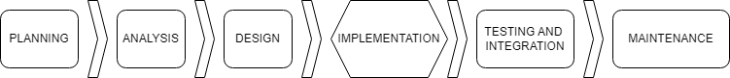

Figure 1. Embedded Product Development Life Cycle

Figure 1 displays the type of researcher that used the embedded product development life cycle model. This model is essential for adequately building the prototype by dividing the procedure into smaller, manageable parts, allowing the proponents to monitor and guide the outcome effectively. The life cycle starts in the planning phase, where the fundamental aspects, such as the objectives of the project, its scope, and what it requires, are defined. Next follows the Analysis phase, during which information regarding necessary inputs is obtained, and then detailed specifications are made. The design phase comes when we think about the system, including its architecture and all its other parts. At this point, we shall move to the implementation phase, which involves coding and hardware development. The next stage is testing and integration, where rigorous tests are conducted on the product to ensure compliance with requirements and proper functioning. Finally, maintenance involves constant support and updates related to solving post-deployment problems, thus preserving its ability to perform effectively over time.

**Conceptual Framework**

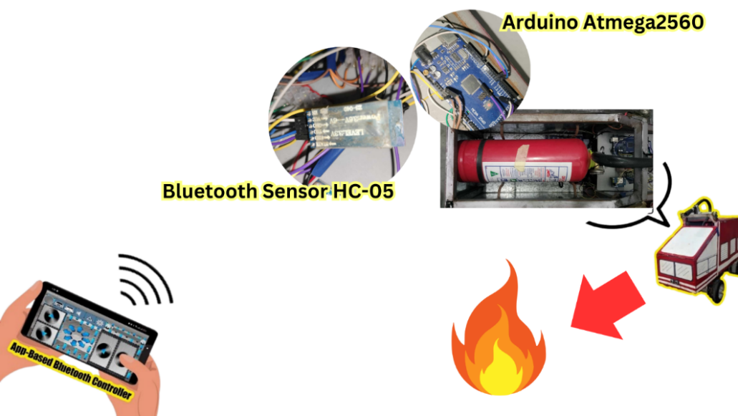

Figure 2. Visual of Robot Controller

Figure 2 illustrates the mobile-based application controller connected via Bluetooth module from the robot, enabling operation within a 10-meter range. This wireless connection allows for real-time communication and precise control of the robot. However, the control range is limited to ten meters.

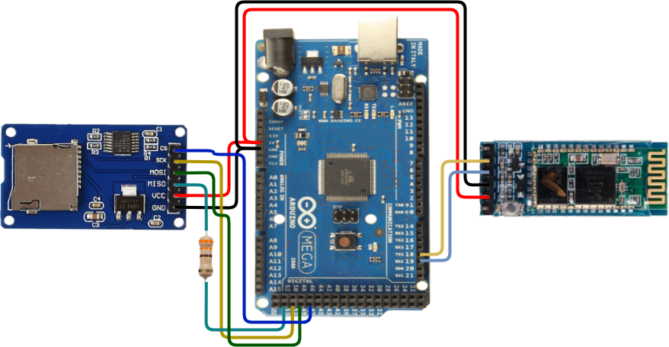

Figure 3. Control System Wiring Configuration

Figure 3 displays an Arduino Mega connected to an SD Micro Card Module responsible for writing and saving data. The Bluetooth Module serves as a communication gateway for Arduino to connect to any Bluetooth-enabled device.

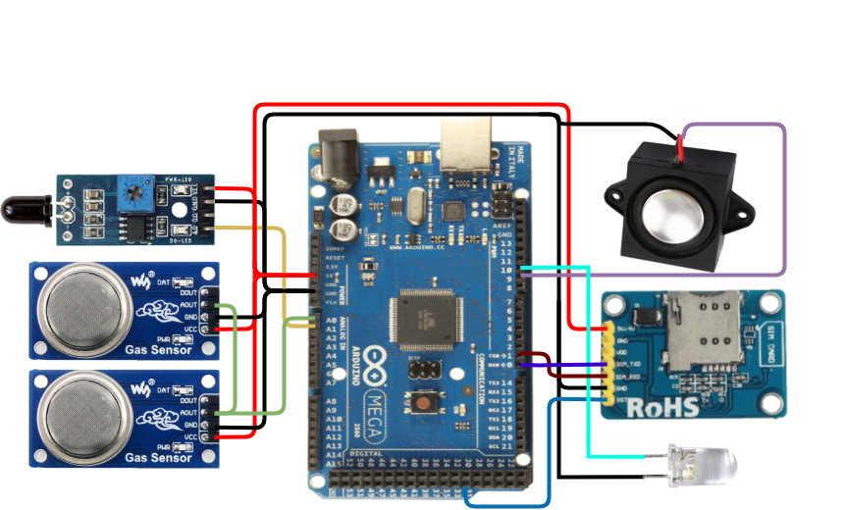

Figure 4. Fire and Gas Detection Wiring Diagram

Figure 4 illustrates an output module on the right and an input module on the right. The input module includes an IR Flame Sensor designed to detect fire and an MQ-5 Gas sensor useful for detecting gas leakage. These two sensors send signals to the Arduino to process and activate the output modules on the right. The Speaker will produce a siren sound, and SIM800L will send an SMS to the registered number upon gas and fire detection.

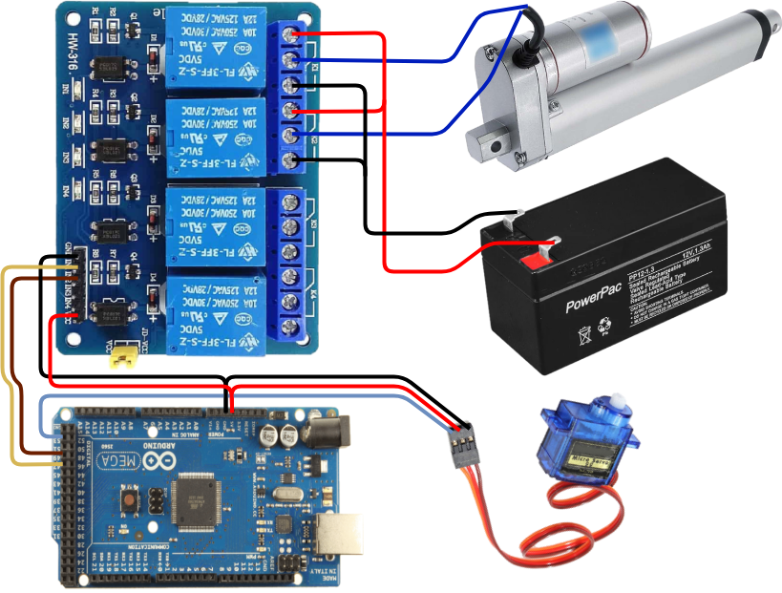

Figure 5. Actuator and Relay Integration

Figure 5 exhibits the Arduino is connected to servo motor and relay which allows low powered microcontroller to power circuit that require much higher energy that is also linked to a 12v battery to enable the actuator to put pressure on the lever of fire extinguisher.

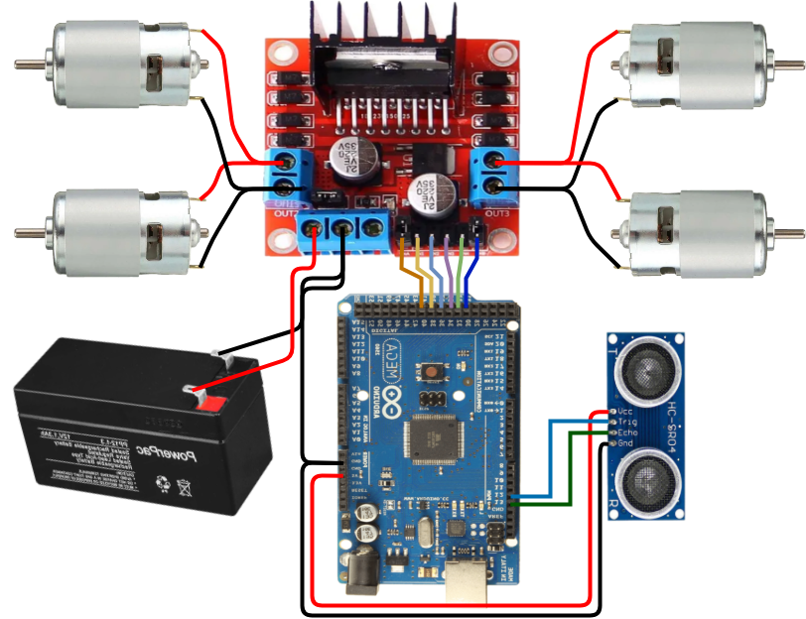

Figure 6. Wiring Diagram of the Firefighting Robot's Motor

Figure 6 shows the Arduino connected to an L298N motor driver that controls the speed and direction of the two groups of Dynamo 775 motors and is connected to a 12-volt battery. The ultrasonic distance sensor inputs a signal to the Arduino indicating how near or far the object in front is, which affects the motor's direction and speed.

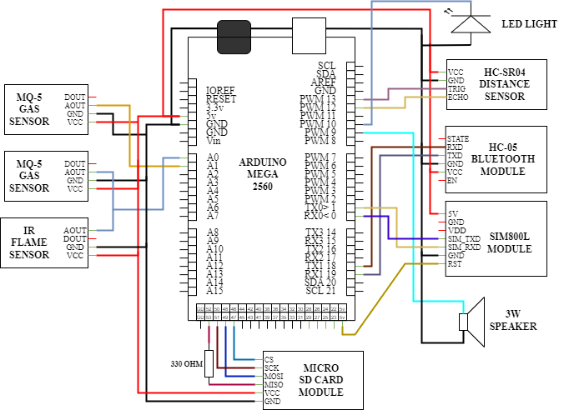

Figure 7. Input Schematic Diagram

Figure 7 outlines a more detailed connection of every pin of an input component, such as the SD Card module MQ-5 Gas sensor, IR Flame sensor, and Ultrasonic Distance sensor. Output components such as the SIM800L module, Speaker, LED light, and Bluetooth module are output and input components connected to Arduino Mega. The red line represents positive terminals, and the black line represents negative terminals; another colour represents every component pin.

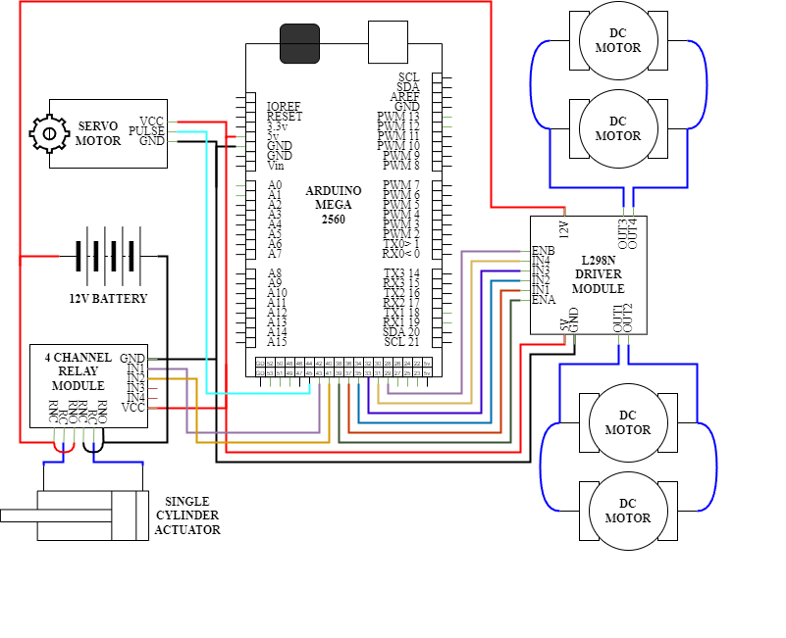

Figure 8. Output Schematic Diagram

Figure 8 displays a thorough connection of output components like the DC motor, Single-Cylinder Actuator, and Servo motor, along with the Relay module and Motor Driver module linked to Arduino Mega. The red line represents positive terminals, and the black line is for negative terminals. Another colour is for the component pin.

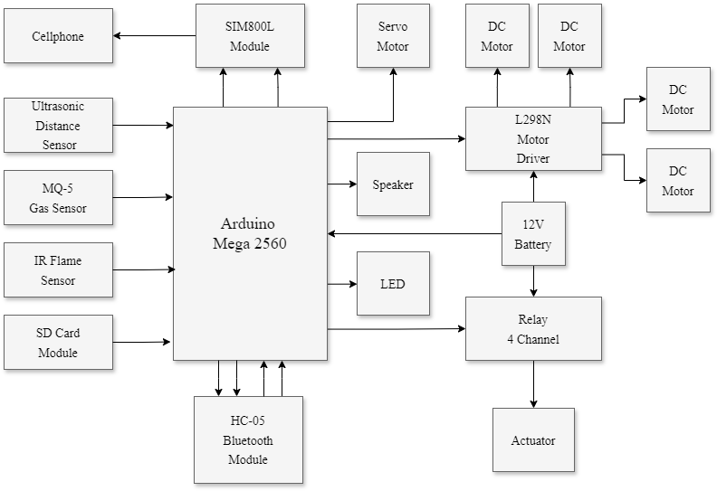

Figure 9. Block Diagram

Figure 9 portrays a complete set up for the robot, which contains the Central Microcontroller together with various electronic parts. The input components are composed of several sensors like UDS, Gas sensor, IR flame sensor, and SIM800L communication module, while the output components include SD Card module, motors, motor controls, relay, actuators, indicators as well as audible devices that are all driven by 12v battery.

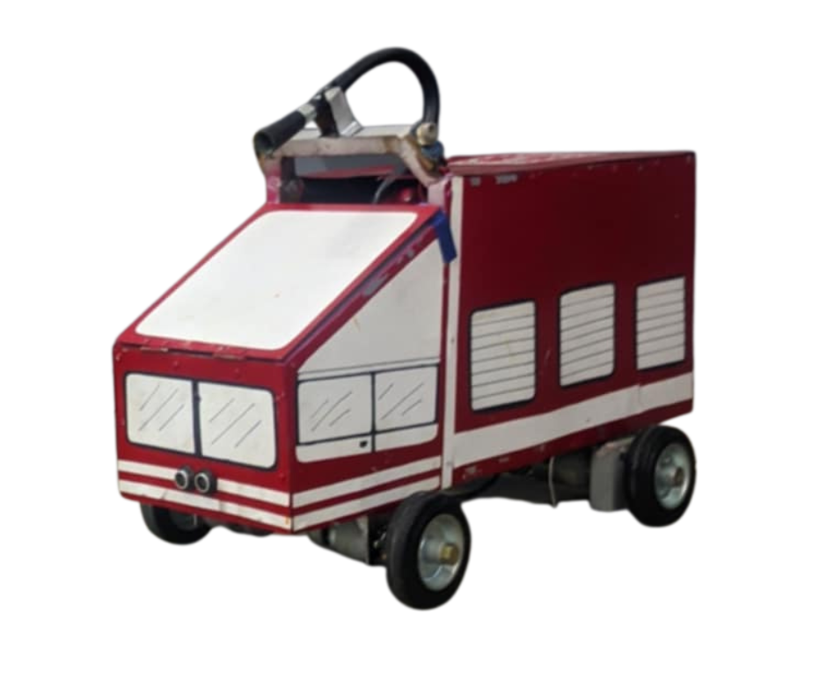

Figure 10. Robot Structure

Figure 10 illustrates the robot's physical structure, designed to maximize the integration of its components. This design ensures efficient use of space, allowing for each integrated part's optimal arrangement and functionality.

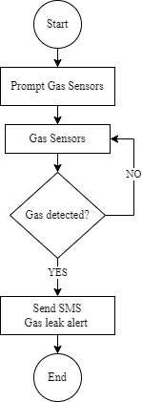

Figure 11. Gas Leak Flowchart

Figure 11 demonstrates how BotBero decides if the sensor detects fire and navigates through the controller until it reaches a distance sufficient to release the liquid and extinguish the fire.

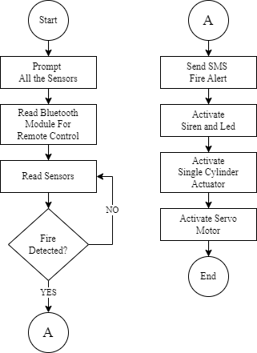

Figure 12. Extinguishing Fire Flowchart

Figure 12 depicts how BotBero will decide if the sensor detected a fire and navigate through the controller until it reaches enough distance to release the liquid and extinguish the fire.

**Statistical Treatment of Data**

The following is the formula to test the of an IR Flame sensor accuracy:

Equation 1

$$Accuracy=\left(\frac{TP + TN}{TP + TN + FP + FN}\right)*100$$

Where:

TN (True Negatives): Number of non-flame situations correctly identified.

FP (False Positives): Number of non-flame situations incorrectly identified as flames.

FN (False Negatives): Number of actual flames missed or not detected.

The formula to test the GSM SIM800L success rate and time efficiency:

Equation 2

$$Success Rate=\left(\frac{Successful SMS Transmissions}{Total SMS Attempts}\right)$$

Time Efficiency (TE):

Equation 3

$$TE =(\frac{Number of Successful Transmissions}{Total Time for Successful Transmissions})$$

**IV. RESULTS AND DISCUSSIONS**

**Testing**

The test run was conducted in the kitchen/dining room environment, utilizing controlled sessions to ensure the accuracy of results. This allowed the researchers to observe and measure in a setting that mimicked real-life scenarios, enabling the robot to achieve practical results.

Bar Graph 1. IR Flames Sensor Accuracy Test Results

Bar Graph 1 illustrates the IR Flames Sensor Accuracy. Out of ten tests with actual flames, the sensor correctly detected eight flames (True Positives) and missed two flames (False Negatives). In the other ten tests without flames, the sensor correctly identified all ten non-flame situations (True Negatives) with no false identifications (False Positives). This results in a total of twenty tests, with ten for actual flames and ten for non-flames.

Calculation for finding Accuracy percentage:

$$Accuracy (\%)=\left(\frac{True Positive + True Negative}{True Positive + True Negative + False Positive + False Negative}\right)*100$$

$$Accuracy (\%)=\left(\frac{8 + 10}{8 + 10 + 0 + 2}\right)*100$$

$$Accuracy (\%)=\left(\frac{18}{20}\right)*100$$

$$Accuracy (\%)=\left(0.9\right)*100$$

$$Accuracy \left(\%\right)=90\%$$

Thus, the accuracy of the IR Flame Sensor is 90%.

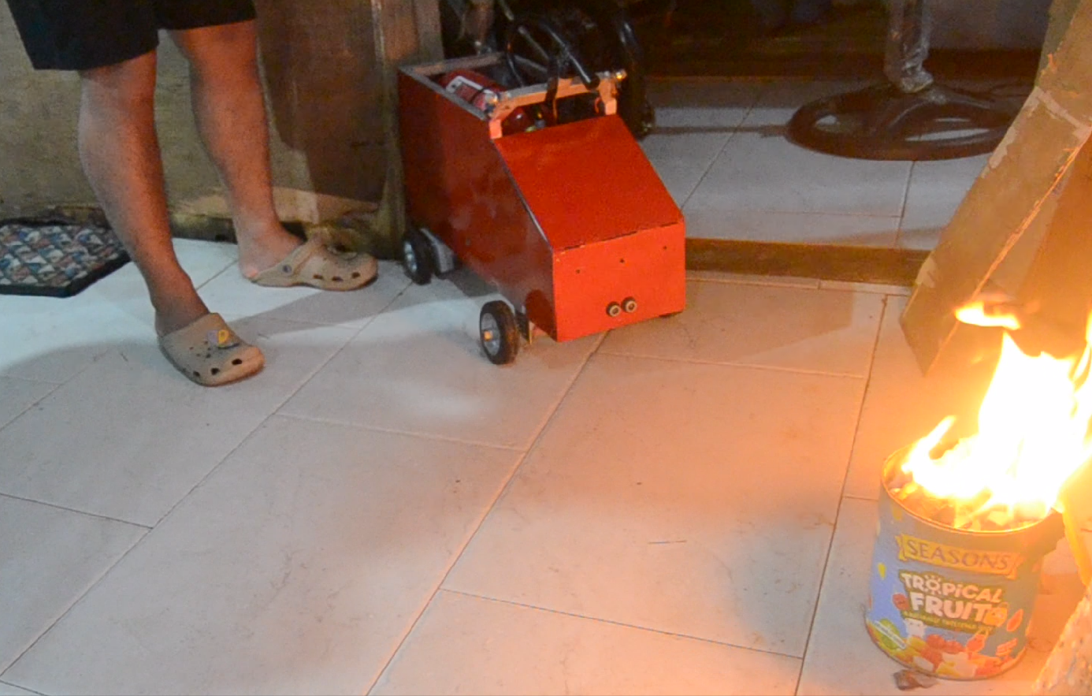

Figure 13. IR Flame Detection Accuracy Visualization

As shown in Figure 13 the robot with a distance of 35 inches far from the fire resulted in 8 true positives (TP) and 10 true negatives (TN), alongside no false positives (FP) but two false negatives (FN), the accuracy of the flame sensor detection system is calculated as 90%. This implies that the sensor correctly identifies flames and non-flame situations with high precision, contributing to its reliability in distinguishing between the presence and absence of flames.

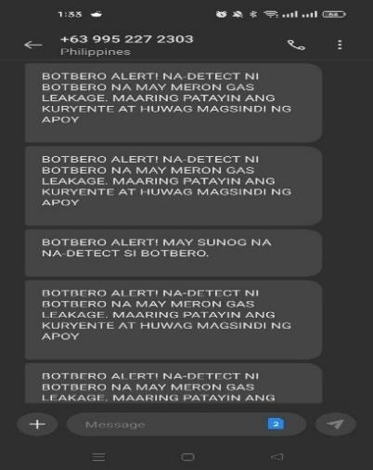

Figure 14. Visual for SMS Received for Fire and Gas Alert

Figure 14 illustrates that the GSM SIM800L module for fire detection SMS alerts achieved a perfect success rate, with all eight attempts resulting in successful delivery. The average time efficiency was 4 seconds per SMS, with delivery times ranging from 3 to 5 seconds. These results underscore efficient performance, especially given the limited number of attempts.

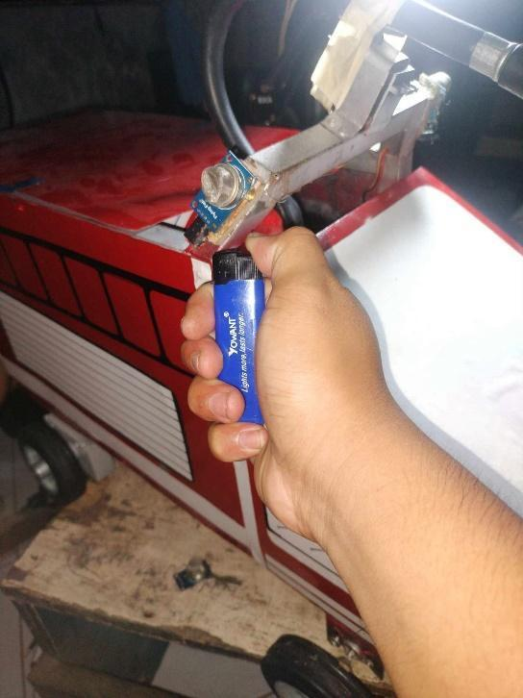

Figure 15. Image of MQ-5 Sensor

Figure 15 demonstrates how the researchers manually triggered the gas sensor in a controlled and safe manner. They carefully followed procedures to ensure accurate testing while maintaining safety protocols.

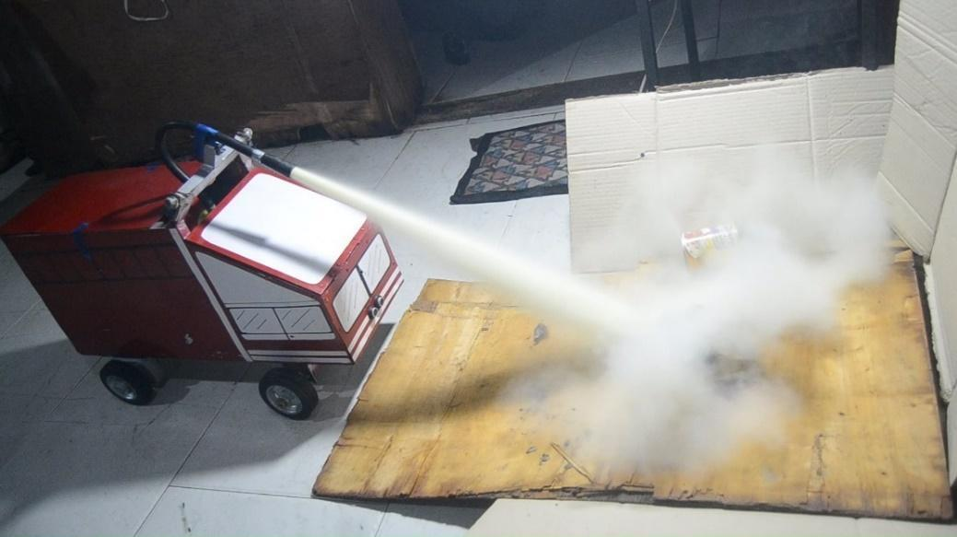

Figure 16. Visual for Suppressing Fire

Figure 16 illustrates the robot in action as it fires a fire extinguisher upon detecting a fire. The image shows that the robot effectively extinguishes the flames, demonstrating its operational capability in emergencies.

**Source Codes**

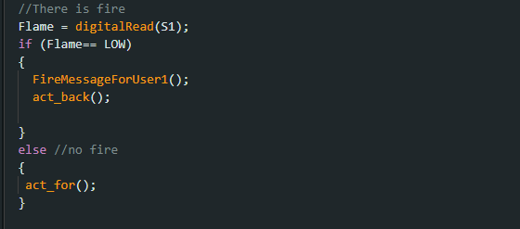

Figure 17. Codes for IR Sensor

Figure 17 shows the code that enables the IR Sensor to perform its function. If the IR Sensor detects a fire, it will send data to the actuator, causing it to pull the fire extinguisher lever and alert the user via SMS. If not, nothing will be done.

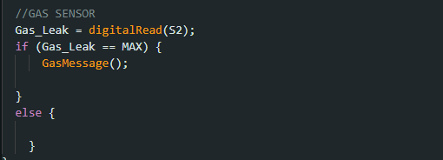

Figure 18. Codes for MQ5 Sensor

In Figure 18 the MQ5 sensor is a versatile device for detecting various gases. These codes enable it to efficiently read and interpret sensor data and notify the user via SMS.

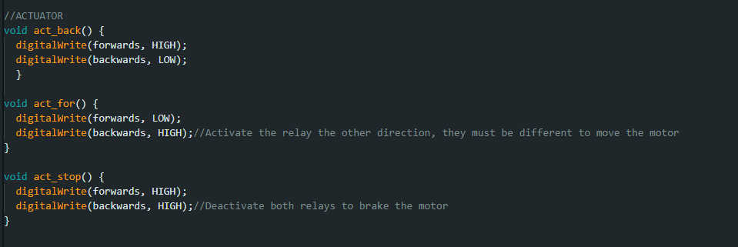

Figure 19. Codes for Actuator

Figure 19 shows the codes control the actuator's motion automatically. When an infrared sensor senses a fire, the actuator activates and presses the fire extinguisher lever.

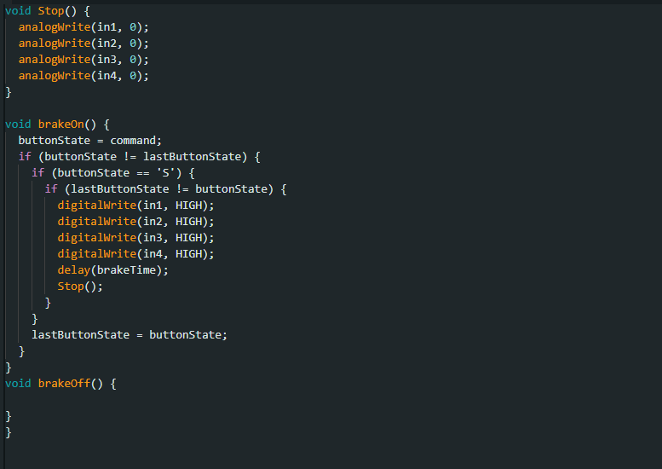 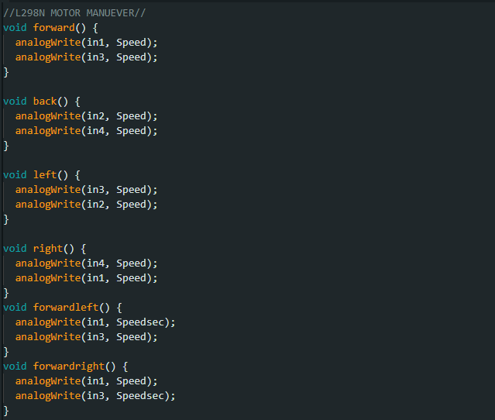

Figure 20. Codes for L298N Motor Driver Module

In Figure 20 the L298N is a dual H-bridge motor driver for bidirectional DC motor control. These codes allow for efficient control of motor function.

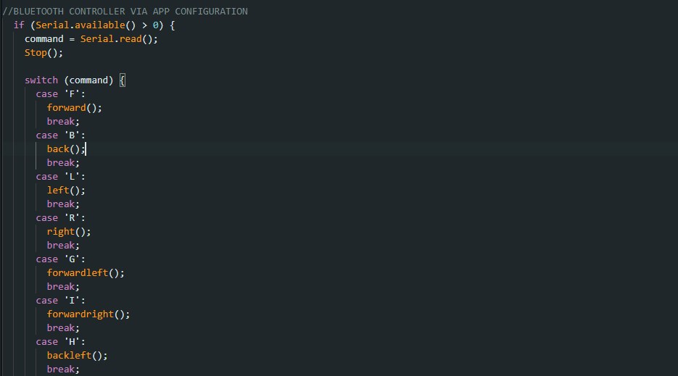

Figure 21. Codes for Bluetooth Controller

Figure 21 using these codes, the user can remotely control the robot. By sending commands via a Bluetooth terminal app, the robot can move forward, backward, turn, and stop.

**Discussion**

Operating the robot remotely until 35 inches away from the fire, the detection system with an inbuilt flame sensor shows an accuracy level of 90%. The system managed to detect fire on eight occasions (true positives); it has also detected no fire in ten cases (true negatives), and this shows its reliability in revealing flame presence. Two incidents of false negatives were evident showing when fires existed but unable to identified. It reassures that it does not have high false alarms.

On the other hand, the GSM SIM800L module that is utilized for fire and gas detection SMS alerts delivered its message effectively in all situations; hence, its success was good. On this reliability SMS alerts were sent out at 4 seconds per SMS on average more than 50% through within time intervals ranging between 3 and 5 seconds which means that it provided an important form of information dissemination just in time.

**V. CONCLUSIONS AND RECOMMENDATIONS**

**Conclusion**

Finally, the robot was designed using an Arduino mega 2560 microcontroller board as well as incorporated all necessary hardware and software components for efficient fire detection and suppression. This enabled seamless functioning and interaction among different elements, ensuring maximum operational efficiency. An important aspect of this implementation therefore was flame-sensor integration that showed an accuracy of 90% at 35 inches ensuring dependable fire detection. Such levels of precision go a long way towards making early identification of sources of fires much easier for the robot itself.

The robot’s coding was done using C++ programming language on Arduino IDE platform which allows for processing sensor data and control commands. Consequently, it accelerated development and debugging processes where robot software is concerned. Testing was done rigorously to confirm the accuracy of the flame sensor thus confirming its effectiveness on fire detection. Additionally, a GSM SIM800L module integrated into the robot can send out an SMS notification system which alerts you within 4 seconds after a fire and gas is detected. Thus, it supports fast reaction time by informing the users quickly. By introducing this SMS system within its architecture, the robot will have better overall functionality including immediate messaging during emergencies.

**Recommendation**

Researchers encountered several problems while making the robot, from which the following recommendations are derived:

1. There is need for camera sensor integration with an Artificial Intelligence system trained through data that involves different intensity level of fire based on visual input to be done by future researchers in the field hence enhancing the ability of the device in detecting/responding to fire under different conditions.
2. Raising the RPMs of the motor as well as gear ratios for the robot to move faster and accommodate for more load.
3. Utilizing Wi-Fi instead of Bluetooth can significantly enhance the robot's operational range and reliability for extended distance control.
4. Extending a device's operational lifespan, consider using batteries made with newer technology. Longer-lasting batteries improve overall efficiency and enhance the usability of the robot.

**Social Implications**

Over-dependence might decrease human skills development, lead to privacy conflicts because they can perform surveillance tasks as well as be involved in other moral arguments such as taking over human decision making.

**Acknowledgement**

Grateful to Dr. Manuel Luis C. Delos Santos, research advisor for giving advice during this project. The second part of appreciation goes out to Asian Institute of Computer Studies (AICS) for facilitating the environment and resources necessary for research. Moreover, appreciate peers who provided their encouragements and valuable suggestions that immensely helped make this work a success at the end.

**DECLARATIONS**

**AI-Assisted Editing**

AI tools were used such as Grammarly and Quilbot exclusively for editing and refining the original content for readability purposes of the research paper. However, AI is not used to generate new content or alter the original ideas and arguments.

**Conflict of Interest**

All authors declared that they have no conflicts of interest.

**Informed Consent**

All participants were appropriately informed and voluntarily agreed to the terms with full consent before taking part in the conduct of the experiment/survey.

**Ethics Approval**

The AICS Research Ethics Committee duly approved this study in conformity to the local and internationally accepted ethical guidelines.

**REFERENCES**

A. K. Raghunath, S. Chandrasekaran, R. R. M. Doss, & M. A. Saleem Durai. (2020). Gas leakage warning system. In 2020 IEEE Student Conference on Research and Development (SCOReD), Batu Pahat, Malaysia, 1-5. https://doi.org/10.1109/SCOReD50371.2020.9383181

Abdulwakil, N. R. N. Z. A. H., Amar, M. J. R., Durante, B., & Santos, C. V. N. R. (2021). Fire-fighting UAV with shooting mechanism of fire extinguishing ball for smart city. Computer Engineering Department, Jose Rizal University, 1320-1326. <https://pdfs.semanticscholar.org/2318/84711030485d2d444b1f69a46600ceeb13ed.pdf>

Alsaad, S. N., & Hussien, N. M. (2021). IoT based message alert system for emergency situations. International Journal of Computing and Digital Systems, 10(1), 101. <http://dx.doi.org/10.12785/ijcds/1001101>

Alshammari, B. F., & Chughtai, M. T. (2020). IoT gas leakage detector and warning generator. Engineering, Technology & Applied Science Research, 10(4), 6142–6146. <https://doi.org/10.48084/etasr.3712>

Aryanti, A., Mekongga, I., & Dewi, R. S. (2021). GPS-based fire detection system (Global Positioning System) and SMS gateway. IOP Conference Series: Materials Science and Engineering, 1108(1), 012023. <https://doi.org/10.1088/1757-899X/1108/1/012023>

Bogue, R. (2021). The role of robots in firefighting. Industrial Robot, 48(2), 174-178. <https://doi.org/10.1108/IR-10-2020-0222>

Chitti, S., Rao, R. P., Padmaja, C., & Kumari, R. D. (2020). IOP Conference Series: Materials Science and Engineering, 981(3). <https://www.proquest.com/docview/2563867003/141D38E14D834762PQ/6?accountid=10098>

Dhiman, A., Shah, N., Adhikari, P., Kumbhar, S., Dhanjal, I. S., & Mehendale, N. (2022). Firefighting robot with deep learning and machine vision. Neural Computing & Applications, 34, 2831–2839. <https://link.springer.com/article/10.1007/s00521-021-06537-y>

Dufour, D., Le Noc, L., Tremblay, B., Tremblay, M. N., Généreux, F., Terroux, M., Vachon, C., Wheatley, M. J., Johnston, J. M., Wotton, M., & et al. (2021). A bi-spectral microbolometer sensor for wildfire measurement. Sensors, 21(11), 3690. <https://doi.org/10.3390/s21113690>

Hermoso, C. (2022). Fire prevention month 2022. Bria News and Update Blogs. <https://www.bria.com.ph/articles/fire-prevention-month-2022/>

Kharisma, R., & Setiyansah, A. (2021). Fire early warning using fire sensors, microcontroller, and SMS gateway. Journal of Robotics and Control (JRC), 2(3), 165-169. <https://doi.org/10.18196/jrc.2372>

Lezcano Sirre, A. (2024). IoT environmental monitoring system using Arduino and NODE MCU ESP8266 (Final degree project). Universitat Politècnica de Catalunya, School of Engineering of Barcelona East, Department of Systems Engineering, Automation, and Industrial Computer Science. <http://hdl.handle.net/2117/405973>

Maltezos, E., Petousakis, K., Dadoukis, A., Karagiannidis, L., Ouzounoglou, E., Krommyda, M., Hadjipavlis, G., & Amditis, A. (2022). A smart building fire and gas leakage alert system with edge computing and NG112 emergency call capabilities. Information, 13(4), 164. <https://doi.org/10.3390/info13040164>

Morchid, A., Jebabra, R., Ismail, A., Khalid, H. M., El Alami, R., Qjidaa, H., & Ouazzani Jamil, M. (2024). IoT-enabled fire detection for sustainable agriculture: A real-time system using Flask and embedded technologies. Results in Engineering, 23, 102705. <https://doi.org/10.1016/j.rineng.2024.102705>

Natividad, L. R. Q. (2021). Initial response intelligent fire extinguisher robot: A prototype. Journal of Engineering Science and Technology Special Issue on ICITE2021, 138–146. <http://jestec.taylors.edu.my/Speccial%20Issue%20ICITE2021/Special%20issue%20ICITE21_11.pdf>

Noorly Evalina, Faisal Irsan Pasaribu, H. Abdul Aziz, & Z. Arifin Gultom. (2023, November 29). The using of ATmega 2560 micro-controller for LPG leakage detection. AIP Conference Proceedings, 2702(1), 050005. <https://doi.org/10.1063/5.0154957>

Rajendran, R., Shivakumar, N., Kumar, U. S., Balaji, B., & Arun, S. (2024). In Proceedings of the 4th International Conference on Robotics, Intelligent Automation and Control Technologies (RIACT2023), Chennai, India, October 20–22, 2023 (Vol. 3216, Article 020005). AIP Publishing. <https://doi.org/10.1063/5.0226499>

Rakesh Rajendran, N. Shivakumar, U. Saravana Kumar, B. Balaji, & S. Arun. (2024, July 29). Design and comparative analysis of multicontrol line tracking robot using Arduino, ATmega 2560, and M-bot for multilevel training purpose imparting quality education. AIP Conference Proceedings, 3216(1), 020005. <https://doi.org/10.1063/5.0226499>

Rita, J. (2023). 2,000 fire incidents recorded so far since January —BFP. GMA Integrated News. <https://www.gmanetwork.com/news/topstories/nation/862578/nearly-2-000-fire-incidents-recorded-so-far-in-2023-bfp/story/>

Roldán-Gómez, J. J., González-Gironda, E., & Barrientos, A. (2021). A survey on robotic technologies for forest firefighting: Applying drone swarms to improve firefighters’ efficiency and safety. Applied Sciences, 11(1), 363. <https://doi.org/10.3390/app11010363>

Sousa, M. J., Moutinho, A., & Almeida, M. (2020). Thermal infrared sensing for near real-time data-driven fire detection and monitoring systems. Sensors, 20, 6803. <https://doi.org/10.3390/s20236803>

Suwarjono, S., Wayangkau, I. H., Istanto, T., Rachmat, R., Marsujitullah, M., Hariyanto, H., Caesarendra, W., Legutko, S., Glowacz, A. (2021). Design of a home fire detection system using Arduino and SMS gateway. Knowledge, 1(1), 61-74. <https://doi.org/10.3390/knowledge1010007>

Talavera, N. F., Roldán-Gómez, J. J., Martín, F., & Rodriguez-Sanchez, M. C. (2023). An autonomous ground robot to support firefighters' interventions in indoor emergencies. Journal of Field Robotics, 40, 614–625. <https://doi.org/10.1002/rob.22150>

Wang, S., Viciano-Tudela, L., Parra, R., Lacuesta, J., & Lloret, J. (2023). Evaluation of suitability of low-cost gas sensors for monitoring indoor and outdoor urban areas. IEEE Sensors Journal, 23(18), 20968-20975. https://doi.org/10.1109/JSEN.2023.3301651

Xavier, K. L. B. L., & Nanayakkara, V. K. (2022). Development of an early fire detection technique using a passive infrared sensor and deep neural networks. Fire Technology, 58, 3529–3552. <https://doi.org/10.1007/s10694-022-01319-x>

Yang, Y., Wang, X. F., Pan, M. Y., & et al. (2023). Evaluation on algorithm reliability and efficiency for an image flame detection technology. Journal of Thermal Analysis and Calorimetry, 148, 5063–5070. <https://doi.org/10.1007/s10973-023-12012-8>

Yang, Y., Wang, XF., Pan, MY. et al. Evaluation on algorithm reliability and efficiency for an image flame detection technology. J Therm Anal Calorim 148, 5063–5070 (2023). <https://doi.org/10.1007/s10973-023-12012-8>

Yumang, A. N., Lazaro, J. B., Ongpauco, J. N. A., Solis, M. V., Aquino, J. -J. M., & Cruz, J. D. R. (2023). Ion-mobility spectrometry – MQ5 sensor system for gas refilling stations. In 2023 IEEE 5th Eurasia Conference on IOT, Communication and Engineering (ECICE) (pp. 212–214). IEEE. <https://doi.org/10.1109/ECICE59523.2023.10383145>

**VI. APPENDICES**

**MANUAL**

The semi-autonomous firefighting robot with SMS notification capabilities can be operated according to the detailed instructions in this user manual. This robot is intended to respond quickly to fire situations; it may be operated from a mobile device and delivers SMS alerts.

**System Overview**

The robot is made to detect and put out fires in a variety of situations. It includes:

* Semi-autonomous navigation
* Sensors for fire detection
* Fire Extinguisher
* SMS alert system for real-time notifications

**Setup Instructions**

1. **Unboxing**: Carefully unpack the robot and its components.
2. **Battery Installation**:
   * Open the battery compartment.
   * Insert the battery and ensure its securely connected.
3. **App Installation:**
   * Download the mobile controller app from the relevant app store.
   * Install and open the app.
4. **Connecting the Robot:**
   * Power on the robot.
   * Connect to the robot's Bluetooth Module through the app.
   * Open the menu tab and select “Connect to Car.”
   * Select car’s Bluetooth module “H-C 2010-06-01” and wait the device to be connected.
5. **Operating Instructions**
   * Launch the mobile controller app.
   * Use the joystick interface to navigate the robot.

(The robot will automatically turn on the fire extinguisher to put out the fire if it finds one.)

**SMS Notification Configuration**

The developer will automatically encrypt the number you provided when purchasing this robot so that you can receive an SMS notification in scenario in which the robot senses a fire.

**Maintenance and Troubleshooting**

* **Regular Checks:** Inspect sensors and suppression system for blockages or damage.
* **Battery Maintenance:** Charge the battery fully before use and store it in a cool, dry place.
* **Troubleshooting:**
  + **Robot Will not Start:** Check battery connections.
  + **No SMS Notifications:** Verify phone number and network connection.

**Safety Precautions**

* Always operate the robot in a safe environment away from flammable materials.
* Do not attempt to modify the robot or its components.
* Ensure that the robot is not obstructed while in operation.

